Hello to Determine PBL Height from the Three Methods and Layer Type Listed for a Sounding

Three Layer Types

1. Convective Boundary Layer (CBL)
   1. This layer occurs during the day, typically in the afternoon. It is turbulent and well mixed (windy, no inversions).
   2. Lasts usually between late morning to early evening.
   3. Heights can vary anywhere between ~1500 meters to ~3500 meters
2. Stable Boundary Layer (SBL)
   1. This layer occurs at night and sometimes during the early morning and late evening.
   2. This layer is not turbulent and not well mixed (inversion, low winds).
   3. Heights can vary anywhere from zero to <500 meters.
3. Neutral Residual Layer (NRL)
   1. This layer most often occurs in the morning and evening hours, the day/night transition.
   2. It exists above the current layer, which is most often a stable layer, and retains the characteristics of the convective boundary layer of the day before.
   3. The height is usually ~500 to ~1000 meters above the actual boundary layer.

Three Methods Overview

1. Richardson Method (Ri)
   1. The lowest height *z* where *Ri(z) = 0.25* is the PBL height for this method.
   2. This method works best in Convective Boundary Layers.
   3. Typically reports low PBL heights in Stable layers.
2. Potential Temperature Method (PT)
   1. This method finds the PBL height at the ***maximum*** vertical gradient of potential temperature.
   2. This method works best when a Neutral Residual Layer is ***NOT*** present.
   3. Typically reports the highest PBL height.
3. Specific Humidity Method (SH)
   1. This method finds the PBL height at the ***minimum*** vertical gradient of specific humidity.
   2. This method works well in all layer types.
   3. Typically reports the middle PBL height.

Tips When Determining Which Method to Use

* Always begin by looking at the potential temperature plot in the lower right hand corner (not the potential temperature gradient method, which is in the upper left)
  + When looking at the potential temperature plot, first look for if Specific Hu and PT methods line up with any lifted inversion on the potential temperature plot.
  + If you need to choose between SH or PT method
    - If you want to choose SH, check to see if a max in PT gradient occurs at the equivalent PBLsh height. If there is correlation, SH method should be a good pick.
* When a Neutral Residual Layer is present
  + The potential temperature (PT) method will usually pick up the residual layer, putting the PBL higher than the other two methods.
    - Example: PT picked up the second lifted inversion around 2800 m, which is due to a Neutral Residual Layer. The Richardson method (Ri) is most near the true PBL height because it is closest to the first lifted inversion

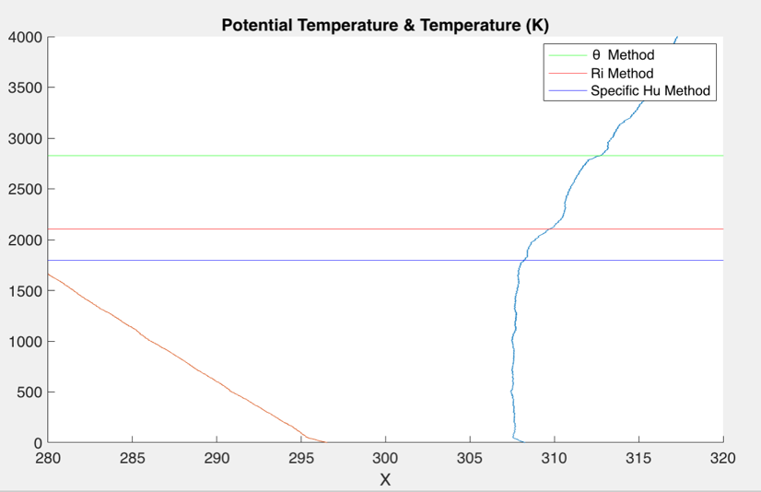and is the highest of the remaining two methods.

Figure 1: temperature is in red and potential temperature in blue. Altitude in meters is on y-axis and temperature in Kelvin on x-axis.

* + When all three methods give very similar results, pick the highest.
    - Example: Specific Humidity is the PBLH method for this sounding.

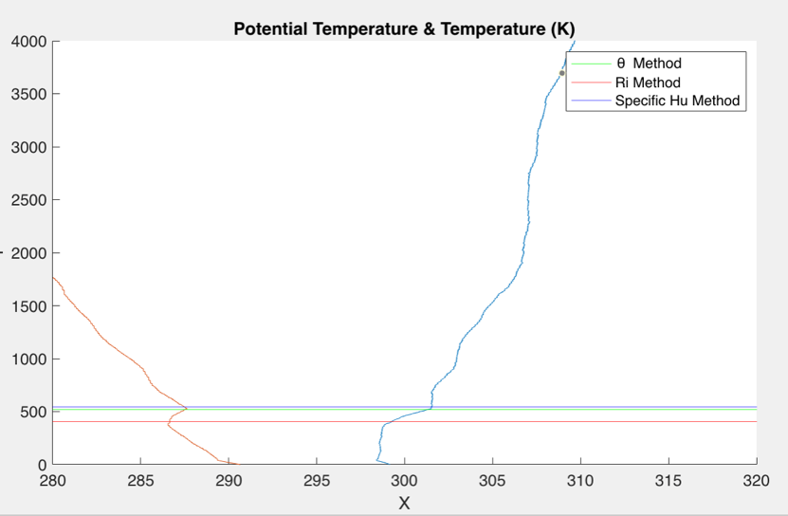

Figure 2: temperature is in red and potential temperature in blue. Altitude in meters is on y-axis and temperature in Kelvin on x-axis.

* When a Stable Boundary Layer is Present
  + Two methods usually will put the PBL height low ( < 20 m) with one slightly higher ( >100 m). In this scenario, pick the highest PBL height
    - Example: In this case, specific humidity method is the PBL height.

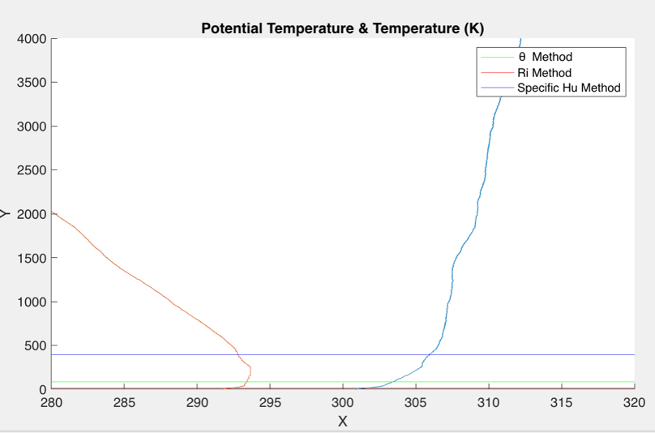

Figure 3: temperature is in red and potential temperature in blue. Altitude in meters is on y-axis and temperature in Kelvin on x-axis.

* + - With a stable boundary layer, a good choice is the highest PBL height as long as it is ~1000 meters or less. Do not choose a PBL height if it is ~2000/3000 meters with a stable boundary layer.
* When a Convective Boundary Layer is present
  + When the three methods are not very close, the Ri method would be the closest to the PBL height
    - Example: Choose red line (Ri)

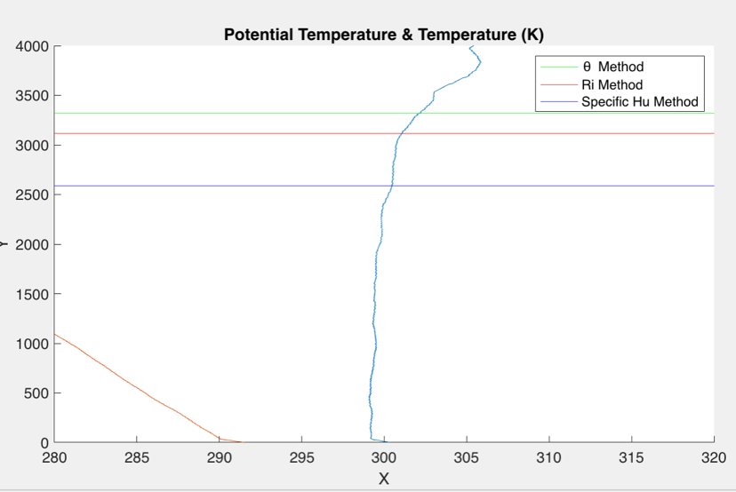

Figure 4: temperature is in red and potential temperature in blue. Altitude in meters is on y-axis and temperature in Kelvin on x-axis.

* When the three methods are very close, choose the highest method.
  + - Example: Choose Green line (PT)

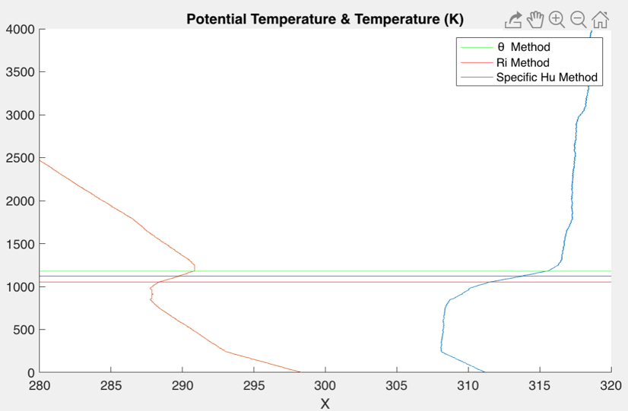

* + When PT and Specific Hu method agree well and Ri is close below, choose highest PBLH.
    - Example: Choose Blue line (Specific Hu)

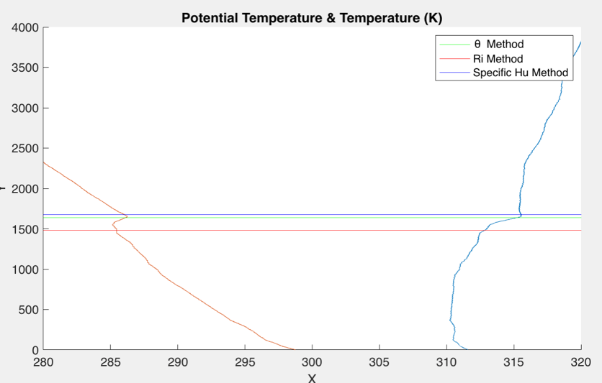

Figure 5: temperature is in red and potential temperature in blue. Altitude in meters is on y-axis and temperature in Kelvin on x-axis.

* + When all three methods are very separated, choose Ri method
    - Example: Choose red line (Ri)

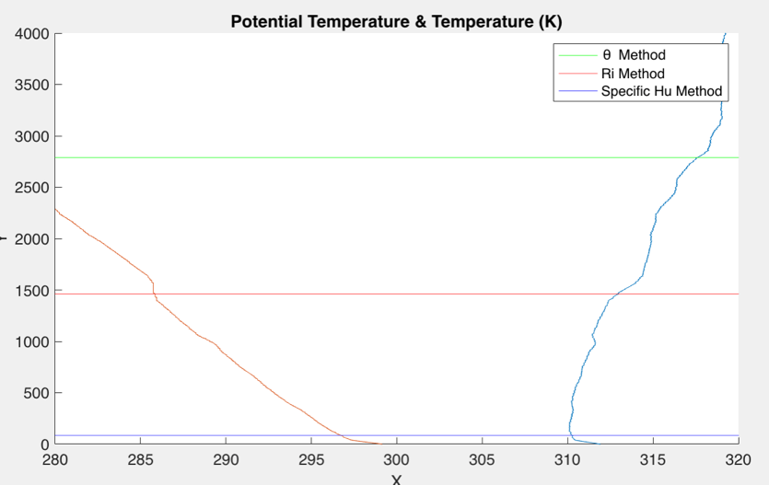

Figure 6: temperature is in red and potential temperature in blue. Altitude in meters is on y-axis and temperature in Kelvin on x-axis.